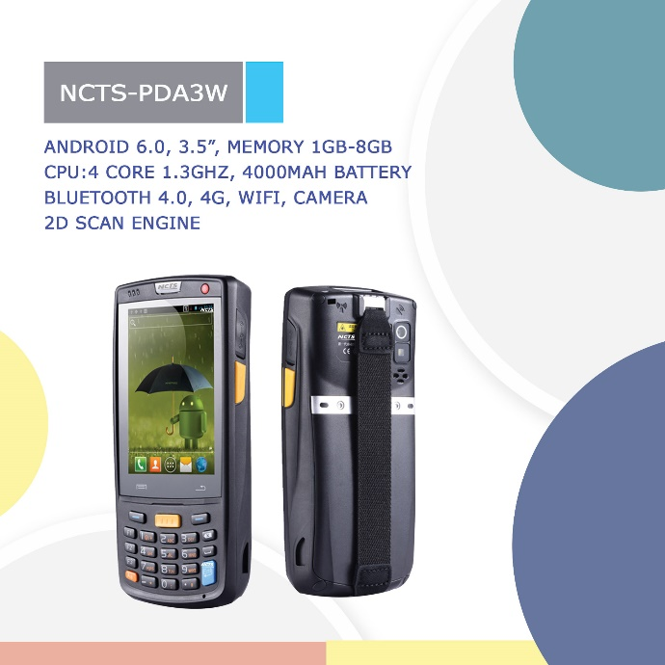
NCTS-PD3W
NCTS-PD3W is a new mobile computer developed by NEW COMPUTER TECHNOLOGY SYSTEMS. for mobile field service. It is designed to connect your mobile workforce to the enterprise for real-time access to business information and data exchange.
Adopting Android 6.0 operating system, the NCTS-PDA3W provides user friendly operation interface, supports versatile functions like 1D/2D barcode scanning, RFID tag reading, infrared communication modules, photographing, GPS, voice communication, and Wi-Fi, NFC and is widely used in various fields, such as, logistics, retail management, meter reading, goods tracking, warehousing, meeting ticketing, and tracing management.
Featuring high performance and high reliability, the NCTS-PD3W can help enterprises boost productivity and gain a higher return on investment.
Five Strengths
- Advanced configuration
- Android 6.0 operating system for more compatibility and better user experience.
- High performance dual-core 1.3GHz processor and 8GB ROM+1GB RAM memory providing higher running speed.
- Industrial-grade capacitive touch panel
- Industrial-grade capacitive touch panel for easy operation and higher flexibility.
- Equipped with a 3.5-inch (640 x 960 pixels) display screen.
- Powerful data collection
- Equipped with advanced scanning engines to read not only 1D/2D barcodes normally printed on traditional media, stained, or covered with plastic film but also barcodes displayed on mobile phones and computer screens.
- Exit window made of Corning® Gorilla® glass for a better scratch-resistance, a higher light transmittance, and more quick and accurate scanning.
- Equipped with built-in RFID read/write modules to quickly and accurately read RFID tags in batches.
- Multiple wireless communication modes
- Supporting multiple wireless communication modes such as WCDMA, GPRS and GSM in a wide area network (WAN).
- Supporting Wi-Fi transmission in a local area network (LAN).
- Supporting a high performance GPS/AGPS navigation chip for more accurate positioning.
- Rugged and reliable mobile computer
- Shell molded at one step using PC engineering plastics of General Electric Company.
- Meeting IP65 sealing standard for superior dustproof and waterproof performance.
- Meeting the 1.5-meter drop specification and the 0.5-meter tumble specification (500 tumbles).
- Keys designed with the IMD film printing technology for scratch-resistance and a longer service life.

Technical Specifications
- System Configuration
CPU | High-performance 1.3GHz quad-core processor
Operating System | Android 6.0
Memory | 8 GB ROM+1 GB RAM
Expansion Slot | Micro SD card, up to 32 GB, Micro SD slot
Display | 3.5-inch (640x960)
Touch Panel | Industrial-grade capacitive touch panel
Camera (Optional) | 8 Mega pixel , autofocus lens, LED flash
Exit Window | Corning® Gorilla® glass
Keypad | 28-key durable industrial keypad with interior transmission light
Battery | 3.7 V 4000 mAh rechargeable lithium polymer battery  (6000 mAh battery optional)
Audio | Built-in microphone
Notification | Vibrator alerts/LED/Audio notification
Vibration Motor | Built-in programmable vibration motor
- Operating Environment
Development Tools | Android SDK+JDK+Eclipse
Programming Language | Java, C
Management Tools | WINSON tools
Operating Temp. | -10℃ to 50℃ (14℉ to 122℉)
Storage Temp. | -20℃ to 60℃ (-4℉ to 140℉)
Relative Humidity | 0 to 95% (non-condensing)
Drop Specification | 1.5-meter drops to concrete ground
Tumble Specification | 500 0.5-m tumbles (1000 hits)
Sealing | IP65
Electrostatic Discharge | Conforms to ± 15 kV air discharge, ± 8 kV direct discharge
- Structural Parameters
Dimensions (LxWxD) | 152 mm x 68 mm x 24 mm
Weight | 255 g (standard battery included)
- Communication Transmission
Wireless Voice Communication | 4G: TDD-LTE：B38/B39/B40/B41；FDD-LTE：B1/B3  3G: WCDMA: 2100MHZ, EVDO 800 MHz, TD-SCDMA:B34/39  2G: GSM/GPRS: 850/900/1800/1900 MHz
Wireless WAN | GPRS/EDGE/ HSPA+/ EVDO /TDD-LTE/ FDD-LTE
Wireless LAN | Wi-Fi 802.11a/b/g/n
GPS | High performance GPS / AGPS navigation chip
- Input/output Prots
USB Port | 1 ( Micro USB port)
Charger Port | 1(Charging interface at the bottom)
- 1D Laser Scanner
Optical Resolution | ≥ 4 mil
Scan Depth of Field | 3.81 cm - 60.98 cm
Scan Angle | 47°± 3° (Standard)
Scan Speed | 102 ± 12 scans/sec. (Bidirectional)
- 1D Linear Imager
Reading Mode | CCD
Reading Accuracy | ≥ 4 mil
Decoding Speed | 300 times/sec. (Max.)
- 2D Area Imager
Optical Resolution | ≥ 3 mil
Scan Angle | Omnidirectional
Scan Speed | 300 scans/sec.
- RFID
Frequency | 13.56 MHz
Reading Distance | Within 50 mm
Protocol | ISO14443A(B)/15693
- Accessories
Standard | Battery, Hand strap, Wrist strap
Optional | Power adapter, USB cable, Bottom charging cable , Single cradle, 4-slot battery charger, Silicon case

www.ncts.co

