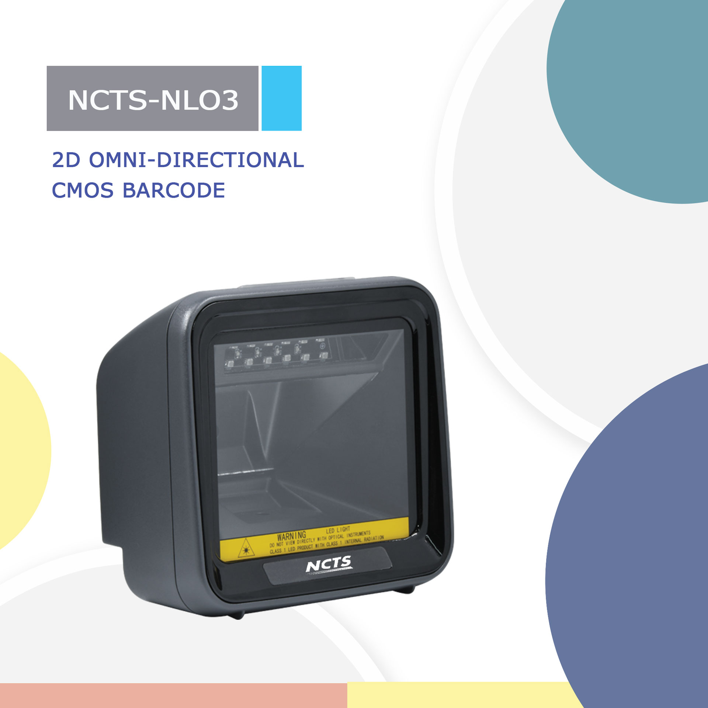
NCTS-NLO3

Version:V1.1
2D Barcode Image Scanner
Technical Specifications
Electrical Characteristics
Interface Supported |  | USB HID KEYBOARD/USB VCP/RS-232
Input Voltage |  | DC 5V±10%
Current |  | Max:200mA
Optical Characteristics
Image Sensor |  | CMOS Array Sensor
Sensor Resolution |  | 1280 X 960 Pixels
Light Source |  | RED LED
Performance Characteristics
Scanning Angle |  | Pitch angle:±60°;Skew angle:±40°;Tilt angle:±180°
Field of View |  | 60°(H),40°(V)
Min Resolution |  | 1D：0.127mm/5mil（PCS 0.9）  2D：0.254mm/10mil（PCS 0.9）
Min .PCS value |  | 〉20% UPC/EAN 13（13mil）
Language |  | Multiple Languages
Data Edition |  | Support for custom data output
Decode Capability |  | 1D : Codebar，Code128,Code39,Code39,Code93,Code11,EAN13，EAN8，GS1-Databar，GS1-128（EAN-128），Interleaved 2 of 5，Matrix 2 of 5，Industry 2 of 5，UPC-A，UPC-E，ISBN，ISSN, Code 11, MSI  2D : PDF417, Data Matrix, QR Code，Micro PDF417，Micro QR Code，Aztec Code
Physical Characteristics
Dimensions |  | 94mm*100mm*152mm(L*W*H)
Weight |  | 265g
Indicator |  | Beeper, LED
Environmental Characteristics
Temperature |  | 0°∽50°C / 32°∽122°F(operation) /-10°∽60°C /14°∽140°F(storage)
Humidity |  | 20 - 85% (operation) ) 20 - 90% (storage)
Shock Drop Test |  | 1.5m drop onto concrete surface
Decoding Depth of Field
Symbology | Resolution |  | Barcode width | Nearest | Farthest
Code 39 | 6.67mil |  | 44mm*15mm | - | 19cm
Code128 | 20mil |  | 62mm*15mm | - | 40cm
EAN/UPC | 13.34mil |  | 42mm*15mm | - | 29cm
QR | 20mil |  | 20mm*20mm | - | 20cm
PDF417 | 6.67mil |  | 55mm*19mm | - | 4cm
PDF417 | 13.34mil |  | 35mm*15mm | - | 23cm

