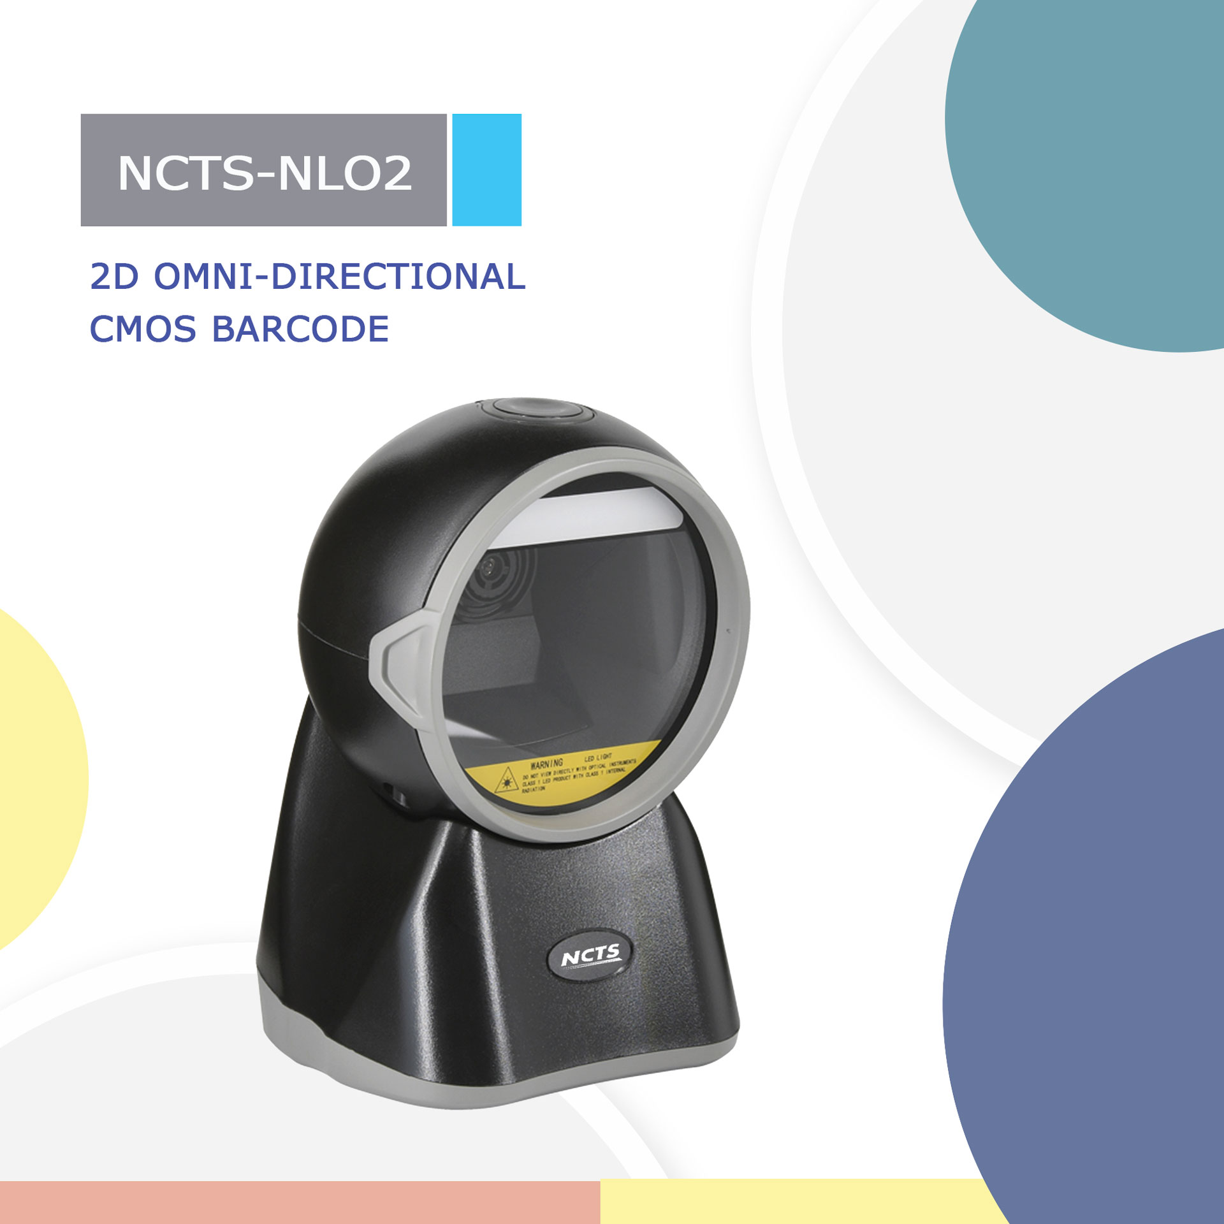
NCTS-NLO2
(2D CMOS Omni-Directional Barcode Scanner)

Technical Parameters
Electrical Characteristics
Interface | USB HID KEYBOARD
Voltage requirement | 5VDC±10%
Current consumption | Max:200mA
Optical Characteristics
Photo sensor | CMOS array sensor
SENSOR RESOLUTION | 1280X800 pixels
Light source | Red LED
Performance Characteristics
Min resolution | 1D:5mil（0.127mil）  2D:10mil(0.25mm)
Min.PCS value | 〉25%UPC/EAN 13（13mil）
Field of View | 39° (H) x 25° (V)
Identification | 1D： Codebar，Code128,Code39,Code39,Code93,Code11,EAN13，EAN8，GS1-Databar，GS1-128（EAN-128），Interleaved 2 of 5，Matrix 2 of 5，Industry 2 of 5，UPC-A，UPC-E，ISBN，ISSN  2D：PDF417, Data Matrix, QR Code，Micro PDF417，Micro QR Code，Aztec Code.....
Physical *Characteristics
Dimensions | 95mm*100mm*158mm(L*W*H)
Weight | 296g
Environmental Characteristics
Temp | 0° to 40°C / 32° to 104°F((operation) )  -40°-to 70°C /-40°to 158°F(storage)
Humidity | 5 - 90% (operation) ) 5 - 90% (storage)
Shock drop test | 1.2m drop onto concrete surface
Ambient Light: | fluorescent light 4000 lx max , direct sun light 80,000 lx max ,white light 4000 lx max
Regulatory
Electrical Safety | UL 60950，EN/IEC 60950
EMI/RFI | FCC Part 15 Class B,EN 55024/CISPR 22
Environmental | RoHS

