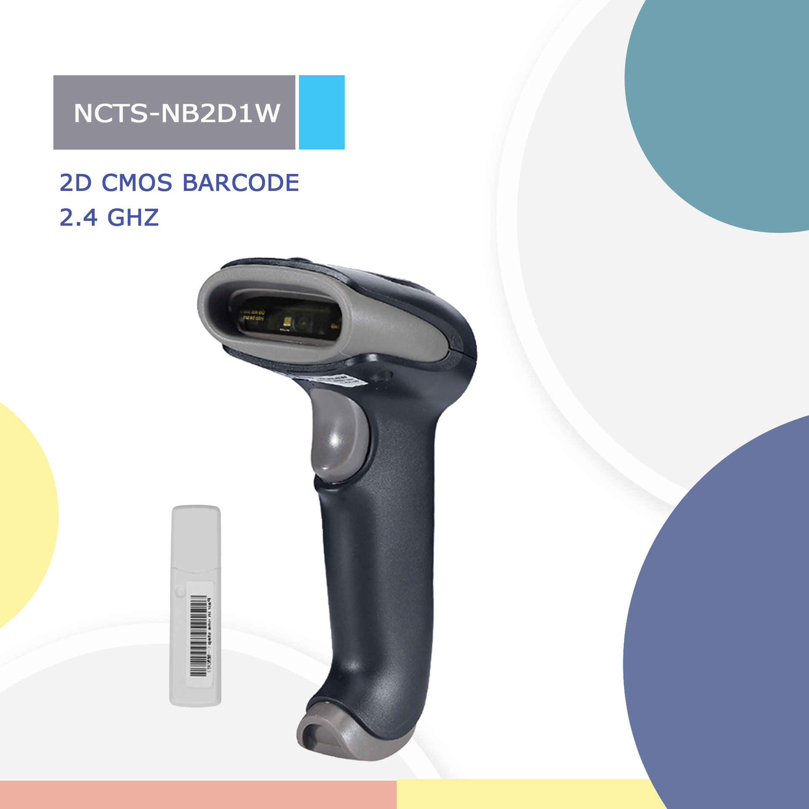
NCTS-NB2D1W
(2D CMOS Wireless 2.4G Handheld Barcode Scanner)
Technical Parameters
Wireless specifications
Communications |  |  |  |  | 2.4GHz
Communication frequency |  |  |  |  | 2.402 to 2.480GHz
Transmission range |  |  |  |  | ≤30M（In empty area 30M ）
Data rate |  |  |  |  | 1Mbps
Memory |  |  |  |  | 100000@13Byte barcode
Battery capacity |  |  |  |  | 1500mAh (Lithium battery)
Charging time |  |  |  |  | 4.5H
The life time of the full charge |  |  |  |  | 4h（continuous reading situation）  9.5h（Manual reading situation）  More than 15 days（Stand-by time)
Communication mode |  |  |  |  | Read-time mode/Inventory mode
Electrical Characteristics
Interface |  |  | USB HID KEYBOARD（Wireless receiver）
Voltage requirement |  |  | Max:120mA  Min：50mA
Optical Characteristics
Photo sensor |  |  | CMOS array sensor
SENSOR RESOLUTION |  |  | 648 X 488 Pixels
Light source |  |  | White LED
Aim light source |  |  | Red Bar LED
Performance Characteristics
Decode angle |  |  | Pitch angle:±60°;Skew angle:±60°;Tilt angle:±180°
Min resolution |  |  | 1D≥4mil  2D≥10mil
Min.PCS value |  |  | 〉15% UPC/EAN 13（13mil）
Field of View |  |  | 46°(H),35°(V)
Identification |  |  | 1D： Codabar，Code128，Code11，Code32，Code39，Code93，Composite，EAN/UPC,EAN-8,EAN-13,GS1 DataBar Expanded，GS1 DataBar Limited，GS1 DataBar Omnidirectional，Hong Kong 2 of 5（China Post），Interleaved 2 of 5，Matrix 2 of 5，Pharmacode.RSS-14,RSS-LIMITED,RSS-EXPANDED,Industrial 2 of 5,Telepen,Trioptic Code, UPC-A,UPC-E  2D：Aztec Code，Codablock F，DOT_CODE, HANXIN, Maxicode，MicroPDF417，Micro QR Code，MSI，PDF417,QR Code, DataMatrix
Physical Characteristics
Dimensions |  |  | Scanner：95mm×70mm×168mm（L x W x H）  Receiver：83mm*18mm*13mm(L*W*H)
Weight |  |  | Scanner：186g  Receiver：16g
Environmental Characteristics
Temp |  |  | 0°∽50°C / 32°∽122°F(operation) /-10°∽60°C /14°∽140°F(storage)
Humidity |  |  | 20 - 85% (operation) ) 20 - 95% (storage)
Shock drop test |  |  | 1.5m drop onto concrete surface
Ambient Light: |  |  | fluorescent light 4000 lx max ,  direct sun light 80,000 lx max ,white light 4000 lx max
 | Decoding Depth of Field
 | Symbology | Resolution |  | Nearest |  | Farthest
 | Code 39 | 20mil |  | 5.5cm |  | 35cm
 | Code 128 | 15mil |  | 6cm |  | 31cm
 | EAN-13 | 13.34mil |  | 6cm |  | 25cm
 | QR code | 20mil |  | 4cm |  | 21cm
 | PDF417 | 13.34mil |  | 3cm |  | 29cm

