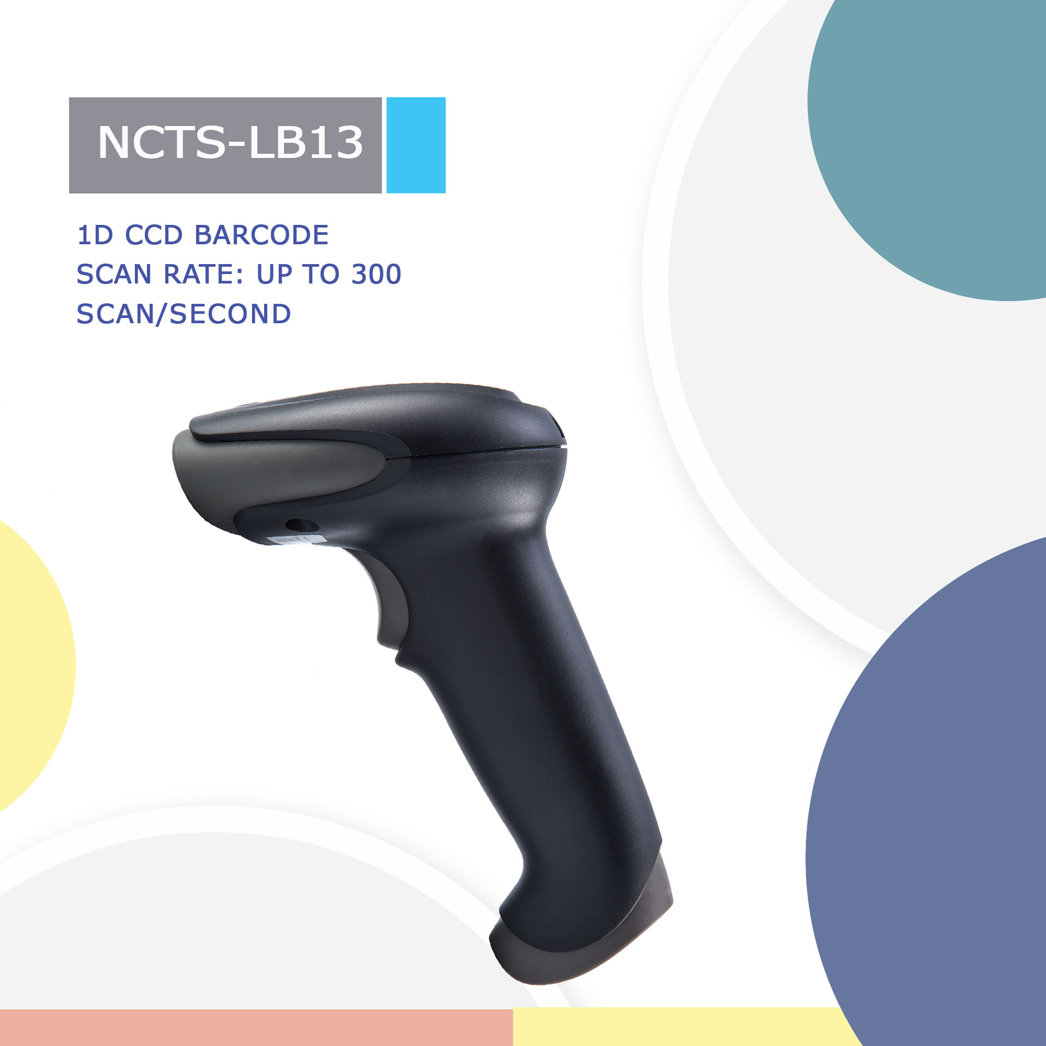
NCTS-LB13
(1D CCD Hand held Wired Barcode Scanner)

Technical Parameters
Electrical Characteristics
Interface | RS-232/USB HID KEYBOARD/USB VCP/RS-485
Voltage requirement | DC5V±10%
Current consumption | Max :138mA
Optical Characteristics
Photo sensor | CCD linear sensor
Sensor Resolution | 2500Pix
Light source | 632nm red LED
Performance Characteristics
Scan Rate: | 350±50 (scans/second)
Decode angle | Pitch angle：±30°  Skew angle：：±75°  Tilt angle：±45°
Min resolution | 0.115mm/4.5mil（PCS 0.9）
Min.PCS value | 〉25%UPC/EAN 13（13mil）
Curvature | R≥15 mm (EAN8)，R≥20 mm (EAN13) （resolution=0.26mm，PCS=0.9）
Language | Multiple languages
Error rate | 1/500W
Identification | EAN13，EAN8，UPC A，UPC E，CODABAR（NW-7），CODE 39，CODE 93，INTERLEAVED 2OF5，STANDARD 2OF5，MATRIX 2OF5，CODE 128，EAN/UCC 128，CODE 11，CHINESE POST
Physical Characteristics
Dimensions | 70mm×95mm×168mm（L x W x H）
Weight | 127.8g
Environmental Characteristics
Temp | -20°-65°C / -4°至 149°F((operation) ) -30°- 70°C /-22°至 158°F(storage)
Humidity | 5 - 90% (operation) ) 5 - 90% (storage)
Ambient Light: | fluorescent light 4000 lx max , direct sun light 80,000 lx max ,white light 4000 lx max
Shock drop test | 1.5m drop onto concrete surface
Regulatory
Electrical Safety |  | UL 60950，EN/IEC 60950
EMI/RFI |  | FCC Part 15 Class B ,EN 55024/CISPR 22
Environment |  | RoHS

Depth of field
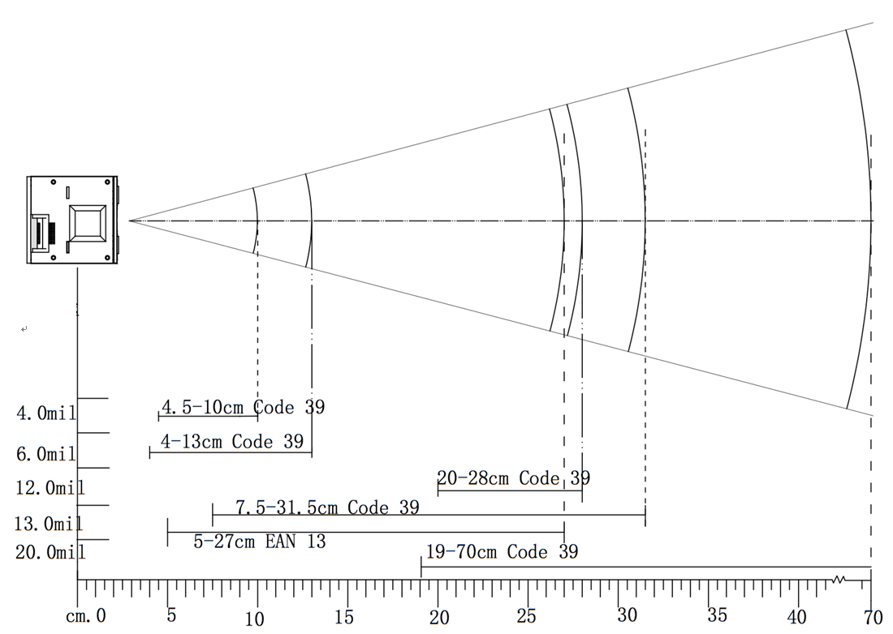

Symbology | Resolution  mm(mil) | Depths of Field | Digits
Code 39 | 0.101(4mil) | 4.5-10cm | 6
Code 39 | 0.152(6mil) | 4-13cm | 12
Code 39 | 0.30(12mil) | 20-28cm | 13
Code 39 | 0.33(13mil) | 7.5-31.5cm | 12
EAN 13 | 0.33(13mil) | 5-27cm | 13
Code 39 | 0.86(34mil) | 19-70cm | 10

