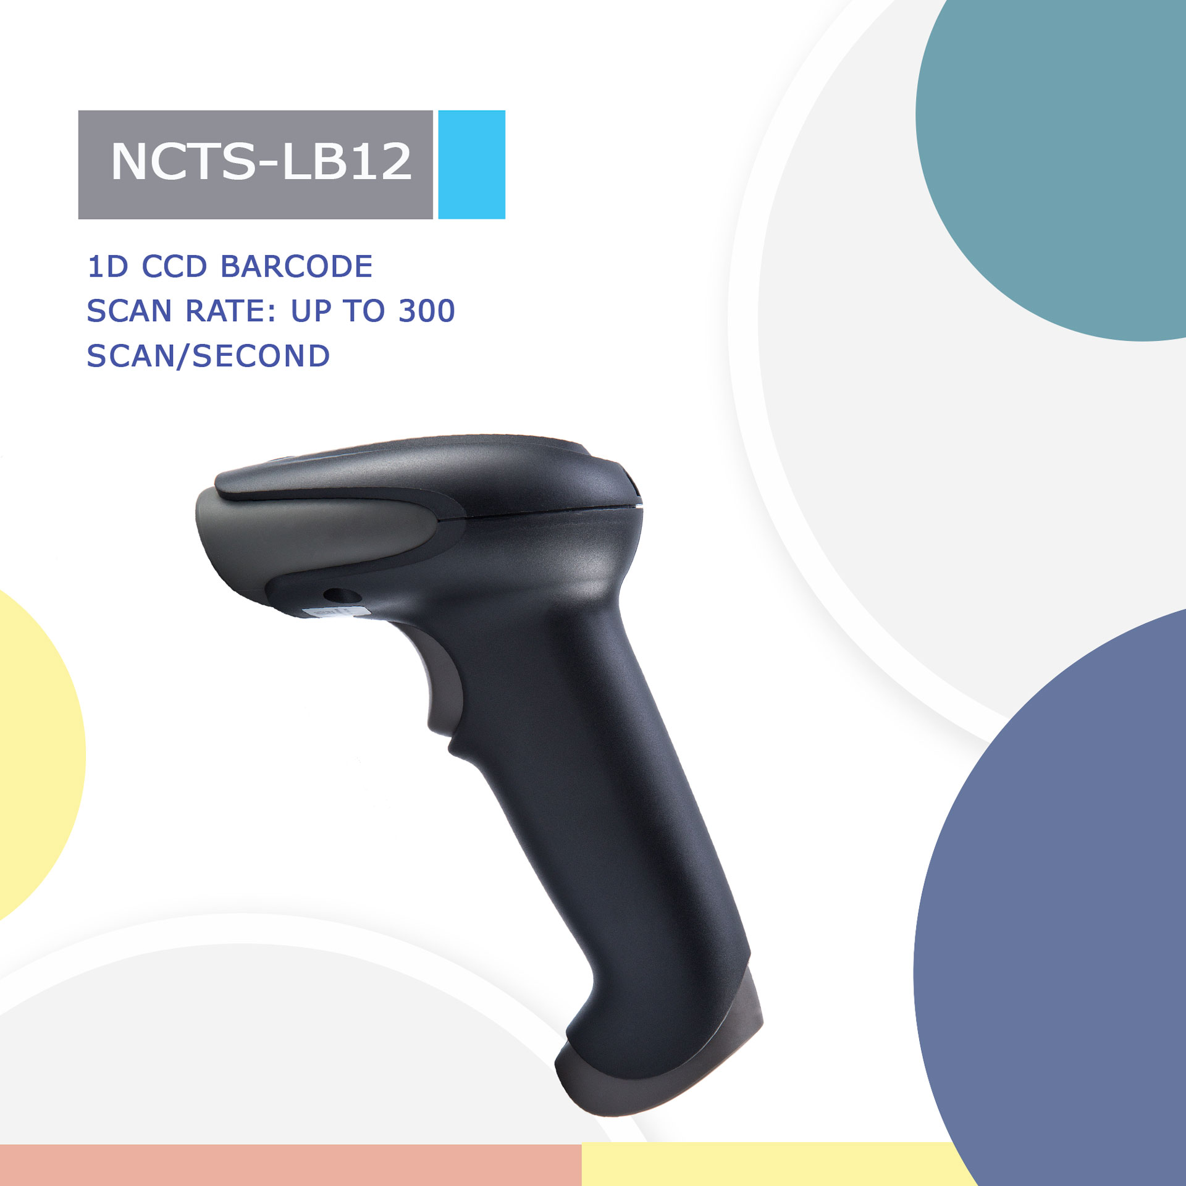

NCTS-LB12
(1D CCD Wire Handheld Barcode Scanner)

Technical Parameters
Electrical Characteristics
Interface | RS232/USB HID KEYBOARD/USB VCP
Voltage requirement | DC5V±10%
Current consumption | Max :138mA
Optical Characteristics
Photo sensor | CCD linear sensor
Sensor Resolution | 2500Pix
Light source | 632nm red LED
Performance Characteristics
Scan Rate: | 350±50 (scans/second)
Decode angle | Pitch angle：±70°  Skew angle：±85°  Tilt angle：±45°
Min resolution | 0.101mm/4mil（PCS 0.9）
Min.PCS value | 〉25%UPC/EAN 13（13mil）
Curvature | R≥15 mm (EAN8)，R≥20 mm (EAN13) （resolution=0.26mm，PCS=0.9）
Language | Multiple languages
Error rate | 1/500W
Identification | EAN-13, EAN-8, UPC-A, UPC-E, ISSN,  ISBN, Codabar, Code 128, Code 93, ITF-6,  ITF-14, Interleaved 2 of 5, Industrial 2 of 5,  Standard 2 of 5, Matrix 2 of 5, GS1 Databar,  Code 39, Code 11, MSI-Plessey, Plessey
Physical Characteristics
Dimensions | 70mm×95mm×168mm（L x W x H）
Weight | 175g
Environmental Characteristics
Temp | -20°-65°C / -4°to 149°F(operation)  -30°- 70°C /-22°to 158°F(storage)
Humidity | 5 - 90% (operation) ) 5 - 90% (storage)
Ambient Light: | fluorescent light 4000 lx max , direct sun light 80,000 lx max ,white light 4000 lx max
Shock drop test | 2m drop onto concrete surface

Depth of field

Symbology | Resolution  mm(mil) | Depths of Field | Digits
Code 39 | 20mil | 5-60cm | 4
Code 128 | 5mil | 4-13cm | 12
Code 39 | 6.67mil | 3-15cm | 16
Code 128 | 15mil | 3-50cm | 7
Code 128 | 20mil | 5-50m | 8
EAN 13 | 13.34mil | 2-40m | 13

