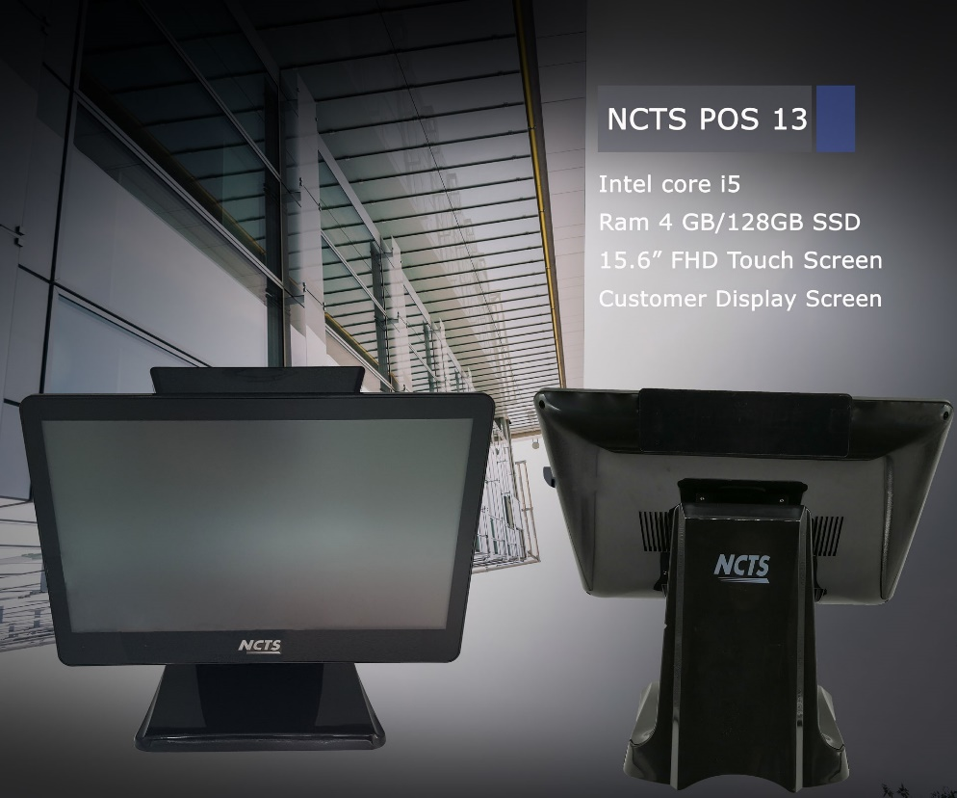
POS13（i5 4G／128G）
Configuration（Model：POS13）
Cabinet size | 460mm(W)*300mm(L)*420mm(H)
Main Board | Industrial POS motherboard
CPU | i5 2.70 GHZ
Memory | DDR 4G
Hard Disk | 128G SSD
Color | Black （Same as photo）
Power supply | 12V/5A 250W/220V/110V ATX Power supply
Interface | USB*6 / Lan * 1 / HDMI *1 / VGA *1 / Audio in and out * 1
Monitor | 15.6-inch LED screen panel
Touch Screen | Capacitive Screen
Customer display | 15'' TFT LCD Resolution
POS keyboard(optional) | NCTS-KB2 keyboard  (Optional: NCTS-KB95 pos keyboard with magcard reader track2+3,or programmable keyboard with magcard reader track2+3)
Barcode scanner(optional) | CCD barcode scanners or Laser barcode scanners/2D scanners
Label Printer(optional) | Industrial or Not-industrial label printer
POS Software（optional） | Retail or restaurant POS software
Operation System(optional) | Win XP, Win 7, 8, 10
Carton box size | 470mm(W)*310mm(L)*430mm(H)
N.W. | 6KG
G.W | 7KG

