NCTS-POS12（4G／128G）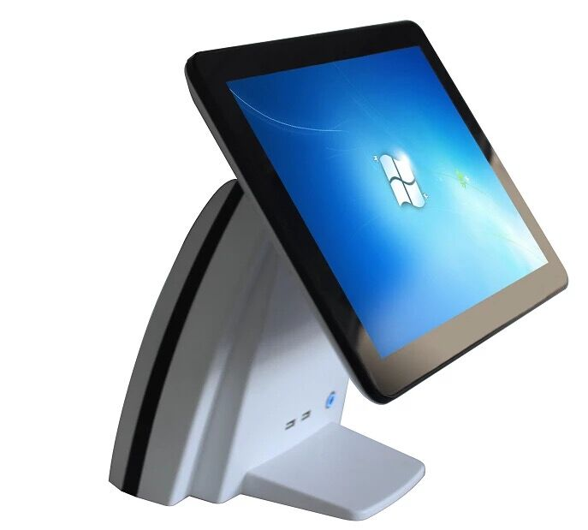

Configuration（MODEL: NCTS-POS12）
Cabinet size | 365mm(W)*340mm(L)*280mm(H)
Main Board | Industrial POS motherboard- Intel 1900
CPU | Dual-core Processor
Memory | DDR3 4G
Hard Disk | 128G SSD
Power | 250W/220V/110V ATX Power supply
Interface | 1 PS/2 mouse & 1 PS/2 keyboard，  1 Parallel port，  6 USB ports，  1 LAN port，  1 VGA port，  1 Serial port  1 Audio output  1 Audio input
Monitor | 15'' TOUCH TFT LCD ELO5 Resistive touch panel--Resolution:1024*768
Printer(optional) | 58mm thermal printer  (Optional:76mm dot-matrix printer, or 80mm thermal with auto-cutter printer)
POS keyboard(optional) | KB-101 keyboard  (Optional keyboard with magcard reader track2+3, or programmable keyboard with magcard reader track2+3)
Cash drawer(optional) | Cash Drawer
Bar code scanner(optional) | CCD bar code scanner or Laser bar code scanner/2D Scanner
Customer display | LED 8N,8digits
Magcard reader, writer(optional) | Track1+2+3,USB port or PS2 port or Serial port
IC card reader, writer(optional) | Contact or Contactless
Password Keyboard（optional） | With LED or without LED

