NCTS NLO2 Highlights
♦ Laser-free Aiming
Laser-free aiming provides an accurate scan indication, creating a customer-friendly operating environment while removing the risk of eye injury.
♦ Interface Flexibility
Choose USB HID KEYBOARD, USB VCP or RS-232 connectivity.
♦ Easily Scans Barcodes on Screens
Easily scans barcodes directly from mobile device or computer screens, almost as if they were printed on paper.
♦ Durable
The NCTS NLO2 can withstand up to drop to concrete from distances as high as 1.2m (4 ft).
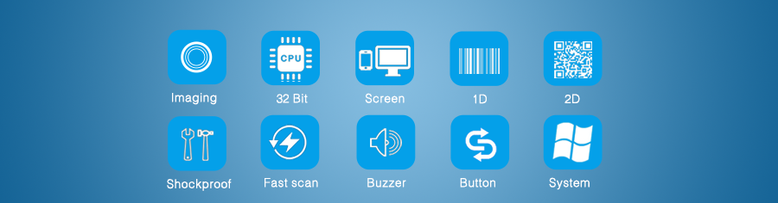
Product Details
Manufacturing, healthcare, retail point-of-sale and other workflow environments often involve mixed barcode applications. If your organization is the same, and you’d benefit from hands-free, presentation scanning, NCTS has just the solution: the NLO2 area-imaging scanner.
Simply put, the NLO2 scanner is a high achiever. It’s the advanced area-imaging scanner engineered to decode all standard 1D, PDF and 2D codes.
Powered by COMS array sensor, the NLO2 is defining industry standards for imaging solutions. It even gives you aggressive reading of barcodes on highly reflective surfaces like mobile phone screens.
Find out more about what your organization can accomplish with the NLO2 area-imaging scanner and NCTS workflow solutions.
► NCTS barcode scanners are compatible with almost all common systems, as Windows, Android, Mac OS, IOS, Linux etc.
► NCTS barcode scanners support multiple keyboard language: USA, Germany, French, Italy, Spanish, Turkey, Belgium, Brazil Czech and so on.
► NCTS barcode scanners are play and play, no need to manual install driver.
► NCTS barcode scanners apply to registry office of the airport/train station, hospitals, warehouses, supermarkets, retail stores, libraries, catering, logistics, express delivery, etc.
► Support multi-barcodes, such as: 1D： Codebar，Code128,Code39,Code39,Code93,Code11,EAN13，EAN8，GS1-Databar，GS1-128（EAN-128），Interleaved 2 of 5，Matrix 2 of 5，Industry 2 of 5，UPC-A，UPC-E，ISBN，ISSN 2D： PDF417, Data Matrix, QR Code Micro PDF417，Micro QR Code Aztec Code

