NCTS NB2D1

Highlights
♦ Reads Bar Codes on Various Media
Not only read codes on printed paper, it could also read codes on mobile phones and computer displays, with this scanner, you will be ready for the coming mobile barcodes revolution.
♦ Superior decoding performance
High resolution:648x488 ,Low decoding error rate can help to improve your working efficiency.
♦ Perfect process design and ultimate experience
NCTS NB2D1 uses imported ABS material, high quality rubber is a good buffer against impact. Nice design makes it different and popular. It applies to cashier for mobile payment and Logistics & Express.
♦ Long life span
Shockproof and Anti-broken
NCTS NB2D1 barcode scanner, after 1.2 drop onto concrete surface floor, still works well.
Famous brand C&k button
NCTS barcode scanner uses world famous brand C&k trigger button, even after 1500，000 times trigger, it still works normally.

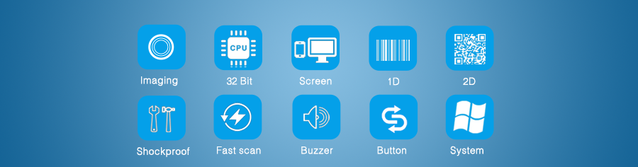
Product Details
► NCTS barcode scanners are compatible with almost all common systems, as Windows, Android, Mac OS, IOS, Linux etc.
► NCTS barcode scanners support multiple keyboard language: USA, Germany, French, Italy, Spanish, Turkey, Belgium, Brazil Czech and so on.
► Support Custom Function: such as add a prefix/suffix, delete the last four characters, interlaced upload data...
► Support self-upgrade, no limitation for Keyboard Cash.
► NCTS barcode scanners are play and play, no need to manual install driver
► Can be adjusted the working mode of barcode scanner according to your own needs, as continuous reading or single reading, scan the same barcode or not, delay the time to upload data or not....
► NCTS barcode scanners apply to registry office of the airport/train station, hospitals, warehouses, supermarkets, retail stores, libraries, catering, logistics, express delivery, etc.
► Support multi-barcodes, such as: 1D: UPC/EAN,Code 128, Code 39, Code 93, Code 11, Matrix 2 of 5, Interleaved 2 of 5, Coda bar, MSI 2D：QR, PDF417, Data Metrix

