NCTS LB1
♦ Support 1D long barcodes
NCTS LB1 Laser Barcode Scanner can read 1D long barcode which length is beyond 10cm, and it can also read the 1D barcode under the direct sunlight.
♦ Excellent decoding performance
Highly sensitive 32Bits CPU, reading speed is up to 100scans/sec, improves the work efficiency greatly.
♦ Install conveniently, operate simply
Plug and Play: No any driver or app needed, USB 2.0 cable wired connection, just insert the data cable into POS, computer or cash register, you can start to scan, Compatible with Windows, Mac, and Linux; works with QuickBooks, Word, Excel, Novell, notepad and all common software’s.
♦ Long life span
NCTS barcode scanner has average 30,000 hours life span, 1.5m drop onto concrete surface still works well.
NCTS barcode scanner uses world famous brand C&k trigger button, even after 1500，000 times trigger, it still works normally.
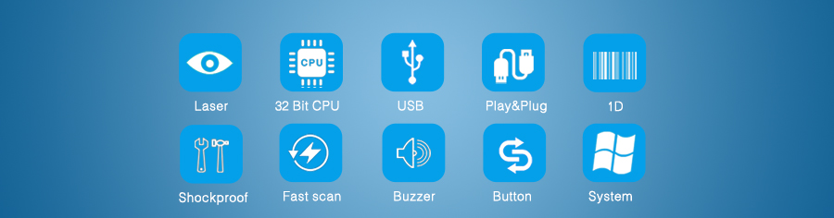
Product Details
► NCTS barcode scanners are compatible with almost all common systems, as Windows, Android, Mac OS, IOS, Linux etc.
► NCTS barcode scanners support multiple keyboard language: USA, Germany, French, Italy, Spanish, Turkey, Belgium, Brazil Czech and so on.
► Support custom function: As add a prefix/suffix, delete the last 4 characters, interlaced upload data.
► Support self-upgrade, as no limitation for Keyboard Cash.
► Can be adjusted the working mode of barcode scanner on the basis of your needs, as continuous reading or single reading, scan the same barcode or not, delay the time to upload data or not.
► NCTS barcode scanners apply to registry office of the airport/train station, hospitals, warehouses, supermarkets, retail stores, libraries, catering, logistics, express delivery, and others.
► Support multi-barcodes, such as: EAN13, EAN8, UPC A, UPC E, CODABAR（NW-7), CODE 39, CODE 93, INTERLEAVED 2OF5, STANDARD 2OF5，MATRIX 2OF5, CODE 128, EAN/UCC 128, CODE 11, CHINESE POST.

